Chapter 8

Comparative Analysis of Machine Learning Algorithms for Intrusion Detection System

P. Agarwal¹, D. Sheth², K. Vaghmare³, N. Sakhare⁴
¹ Student, Computer Engineering, VIIT, Pune, agarwal.pratyaksh99@gmail.com
² Student, Computer Engineering, VIIT, Pune, deepsheth3@gmail.com
³ Architect, Data Competency, Persistent Systems Limited, Pune, kaustubh_vaghmare@persistent.com
⁴ Assistant Professor, Computer Engineering, VIIT, Pune, nitin.sakhare@viit.ac.in
Abstract. The use of machine learning in cybersecurity has emerged as quite a natural next step in modern network intrusion detection systems. As the whole world is moving towards a digital first economy, the number of people with malicious intent who wish to exploit weaknesses in any system, have also increased proportionally. Intrusion Detection Systems (IDS) perform anomaly/outlier detection to distinguish anomalous traffic from normal traffic. We have performed a comparative study of several machine learning techniques on the well-known NSL-KDD Dataset, and analyzed their effectiveness for anomaly detection. We have, in particular, analyzed the use of OneClass SVM, Isolation Forest, Auto Encoders, and traditional binary classification algorithms. Based on our research, we have accrued that a system of stacked autoencoders is the most efficient and accurate solution for creating a network intrusion detection system.
Keywords Anomaly Detection, Autoencoders, Machine Learning, Intrusion Detection System, Cybersecurity

  - Introduction

Applications of Machine Learning (ML) can now be found in most fields of research. As internet-based activities expand, the need to monitor the network traffic from these activities increases. Organizations use security information and event management (SIEM) to automate this process of monitoring traffic and to bolster their defence against possible threats. It can also generate a response in case of an attack. Such systems are often referred to as SOARs (Security Orchestration and Adaptive Response).

An Intrusion Detection System (IDS) is a system which monitors network traffic for anomalous behaviour. It sends an alert to the SOC team in case it encounters suspicious activity on the network. It can either be a part of the SIEM or something which consumes the data collected by a SIEM. It uses multiple different tools to classify data as normal or anomalous, and in case of anomalous, it can further identify the exact attack type. The training data used in this case can be derived from historical data collected and analyzed by the organization.

IDS can detect attacks through various techniques such as signature-based detection and anomaly detection. In case of signature-based detection, the IDS has a predefined directory of known threats, and can flag the data as anomalous if it matches a record from the directory. This is coupled with anomaly detection, where any traffic which has inconsistent behaviour is reported to the SOC team. Unlike signature-based detection, there is no fixed method to flag data as anomalous, but rule-based classifiers and machine learning models trained on Normal data can be used to detect outliers.

Anomaly detection faces numerous challenges, as normal traffic flow can be similar in nature, but different anomalies are different in different ways. This uncertainty for classification often leads to false alarms, and occasional intrusions. Thus, IDS must be fine-tuned to organizations specific needs and must be fed with new data periodically. Anomalous behaviour can be masked using techniques such as packet fragmentation, which fragments the packets to avoid crossing the threshold. Proxying is used in case the original IP address has been blocked. Even a small change in pattern can be used to breach the defence of the IDS.
Considering these issues, IDS is generally trained on normal data. As normal data is mostly similar in nature and generally follows a pattern, a model that has been trained using normal data can flag any activity that does not fit the pattern as anomalous. Based on our analysis, we have understood the fact that such a model has a higher accuracy and precision compared to traditional binary classification models. IDS can only detect anomalous behaviour and report it, but it cannot take direct action to prevent it, so it is coupled with the security orchestration, automation, and response (SOAR) systems.
In this research work, we have used various anomaly detection techniques such as OneClass Support Vector Machine, Isolation Forest, Autoencoders (single and stacked), and binary classification techniques using traditional algorithms such as random forest classifier, logistic regression, AdaBoost classifier, linear support vector classifier, and stochastic gradient decent classifier. A comparative analysis consisting of the aforementioned machine learning techniques is performed to identify the most suitable technique for anomaly detection.

  - Related Work
Gharib et al used stacked autoencoder which consisted of a normal autoencoder, followed by a sparse autoencoder [1]. Ravipati et al performed feature extraction and used multiple “weak” classifiers and combined them to form a strong classifier [2]. Dhanabal et al performed a detailed analysis of NSL KDD dataset and used J48, SVM, and Naïve Bayes as classifiers after using feature extraction [3]. Hasan et al used a combination of support vector machines with different kernels [4]. Homoliak et al used artificial neural network with back propagation [5]. Imran et al used a combination of neural networks and SVM with different kernels. Revathi et al used J48, CART, Random Forest Classifier and Naïve Bayes on NSL KDD [7]. Tavallaee et al suggested various methods for preprocessing operations on the NSL KDD dataset, which reduces wrong detection of records [8]. The goal of this survey, according to Raghavendra Chalapathy and Sanjay Chawla, was to investigate and uncover numerous deep learning models for anomaly detection, as well as analyse their viability for a given dataset. These assumptions can be used as a guide when applying a deep learning model to a certain domain or collection of data to assess the technique's efficacy in that domain. They also state that extending and updating this study in the future may be necessary when more complex methods for deep learning-based anomaly detection become available [9]. This learning problem is interpreted as a binary classification problem by Ingo et al, who compare the resulting classification risk to the conventional performance metric for the density level problem. The empirical classification risk appears to be a useful empirical performance metric for the anomaly detection problem. This allows them to propose an anomaly detection support vector machine (SVM) for which universal consistency can be easily established [10]. Command sequence learning, according to Terran Lane and Carla E. Brodley, can be a useful technique in the domain of anomaly detection for user recognition in computer security [11]. Sakhare et al used J48 algorithm to detect anomalous behaviour of criminals [12].
  - Methodology

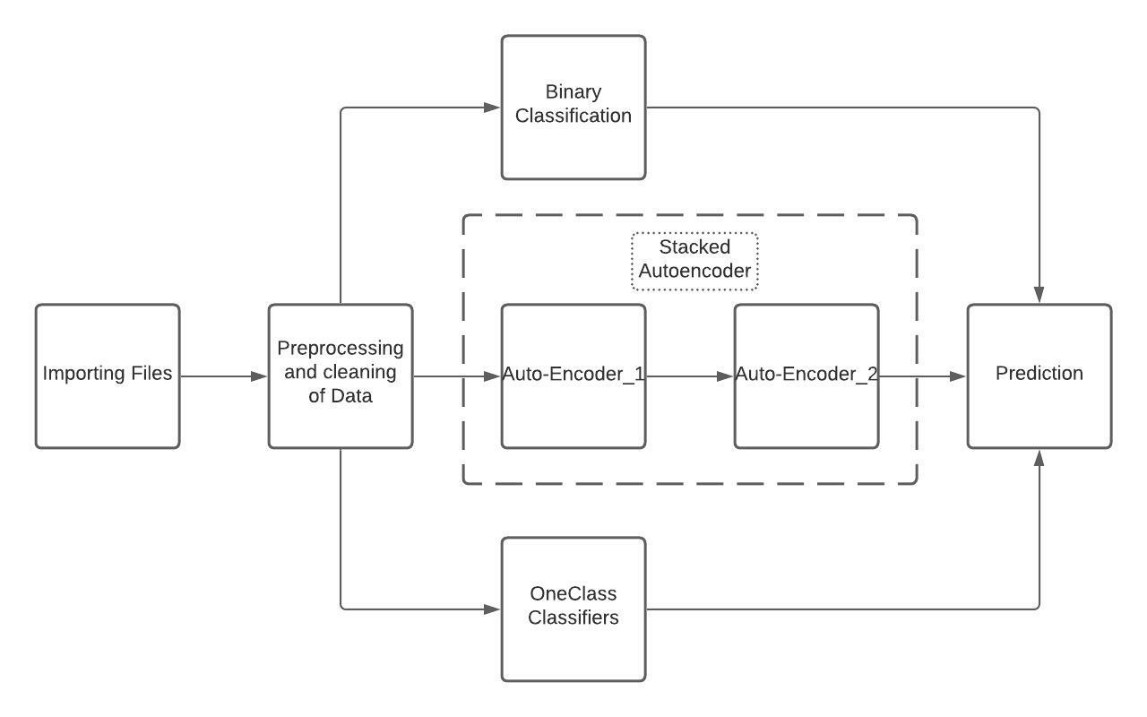
Fig 8.1 Architecture of proposed system

Pre-processing data includes –
- One Hot Encoding the categorical columns.
- Standardization.
- Labelling the 39 different attack types as Anomaly.
- Creating a new train dataframe which includes only the normal samples from the train dataset for one class classifiers and autoencoders.
    - Dataset

NSL-KDD was used as dataset to train our models. It is a pre-processed version of the KDD-CUP 99 Dataset. We used the train and test csv files, which had 1,48,517 records in total. First, we changed all attack types into two classes, ‘anomaly’ and ‘normal’. For the training dataset, we used only the records which were labelled as normal for training our autoencoders, OneClassSVM and Isolation Forest. For binary classification, all records were used. One Hot Encoding was performed on 3 columns with string values. As the magnitude of difference in values was too high, standard scaling was used on the dataset.
We used a variety of techniques to conduct the analysis, which can be divided into three categories: binary classification using popular algorithms, neural network based autoencoders, and conventional unsupervised algorithms that train on a single class.

    - Binary Classifiers

Predicting one of two classes is binary classification. The objective of a binary classification challenge is to develop a machine learning model that can make a prediction when the thing to predict has only two potential values. In our case it can either be normal traffic or an anomaly.
We have trained all the binary models on a dataset which had two labels, i.e., we transformed the 4 attack classes into 1 label as anomaly.

We have used the following binary classifiers:
- Random Forest Classifier
- AdaBoost
- Logistic Regression
- Linear SVC

      - Random Forest Classifier

Random Forest Classifier creates a set of trees from randomly selected subsets of the data. It used bagging and feature randomness when building a tree to try to create an uncorrelated forest of trees whose prediction by committee is more accurate than that of any individual tree.
We got an accuracy of 76% using the Random Forest Classifier.
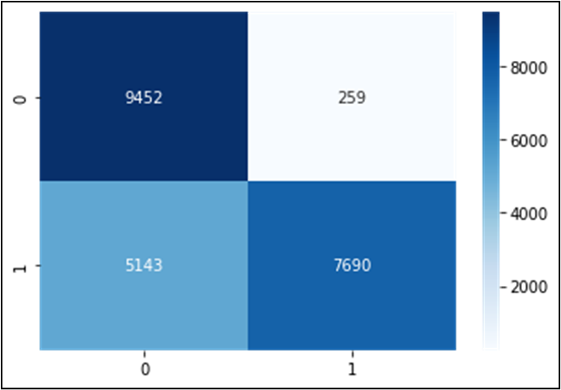
Fig 8.2 Heatmap of RFC

      - AdaBoost Classifier

Adaptive Boosting, or AdaBoost, is a binary classification technique that can only be used for binary classification. The weights are re-allocated to each instance, with higher weights applied to improperly identified instances. This is termed Adaptive Boosting.

In the binary classification category, AdaBoost did the best.

We achieved a 79.1% accuracy rate.

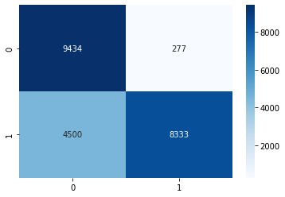
Fig 8.3 Heatmap of AdaBoost

      - Logistic Regression Classifier

Logistic regression is a linear classifier which uses a linear function
f(x)= b₀ + x₁b₁ + x₂b₂+ … + x_{n}b_{n} | (1)

where b₁, b₂… b_{n} are the coefficients of the line of the perfect fit.

Once the coefficients of the best line are found, one can get the predicted output for any value of x_{i}.

Logistic Regression gives an accuracy of 73.6%.

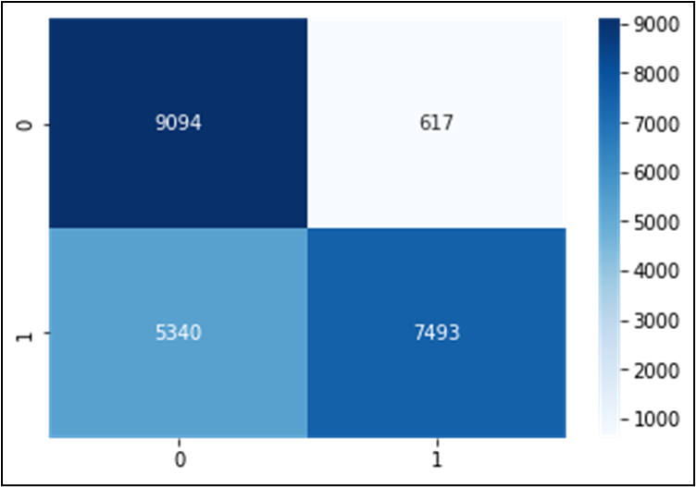
Fig 8.4. Heatmap of Logistic Regression

      - Linear Support Vector Machine

When training the model, Linear SVM constructs a line between the two classes. In this case, Linear SVM performs fairly and has an accuracy of 78.4%.

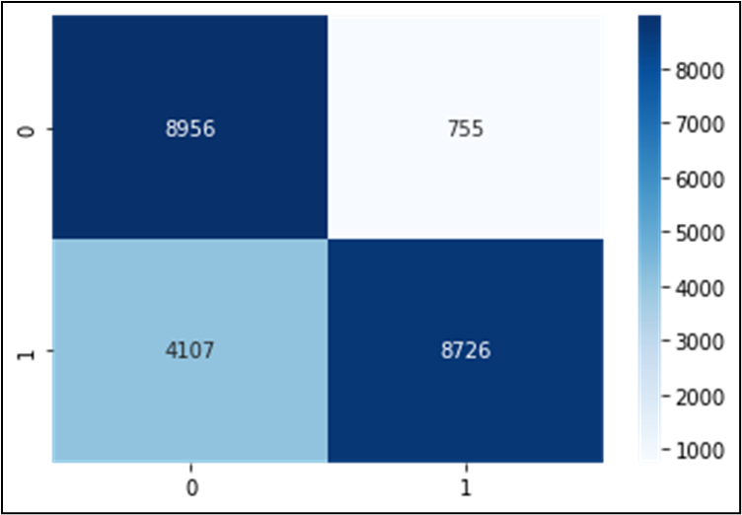
Fig 8.5. Heatmap of Linear SVM

    - One Class Classifiers

One Class classification is a sub-field of machine learning which deals with severely skewed datasets. Binary classification is ineffective when the data is imbalanced beyond a limit. The major application of one class classifiers is in the field of anomaly detection or outlier detection. Here the model trains on one certain class and classifies anything which doesn’t fit the pattern of the class it was trained on as an outlier or an anomaly. In case of an intrusion detection system where anomalies would be rare, one class classifiers provide an effective solution. The training data had only one label class, it only included “Normal” class of data.

The classifiers we used are the following:
- OneClassSVM
- Isolated Forest

      - OneClass SVM

The OneClassSVM is a variant of Support Vector Machine. It's an unsupervised outlier identification model that works well for detecting anomalies. OneClassSVM draws a line around a cluster where the majority of the normal data points are located, and all points outside the line are deemed anomalies.
After modifying the parameters to match our data, our accuracy increased to 75.6 percent.

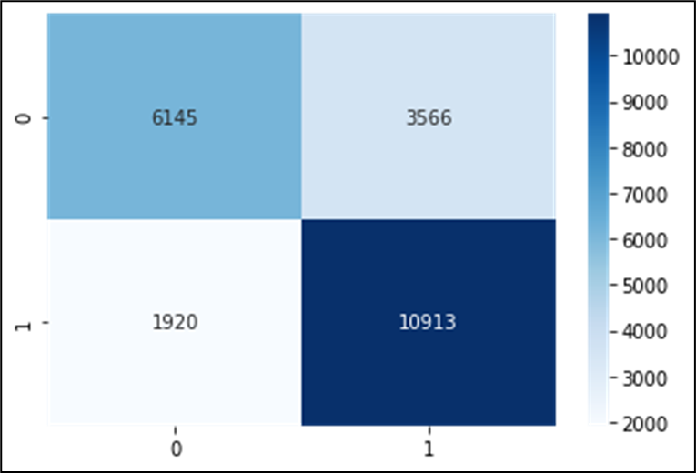
Fig 8.6. Heatmap of OneClass SVM

      - Isolation Forest

The primary concept of Isolation Forest varies from other common outlier detection algorithms in that it discovers abnormalities directly rather than profiling typical data points. Isolation Forest, like any other tree ensemble method, is built on decision trees. In these trees, partitions are created by selecting a feature at random and then choosing a random split value between the feature's minimum and maximum value.
Our accuracy after fine-tuning the model to suit our needs is 80.8 %.

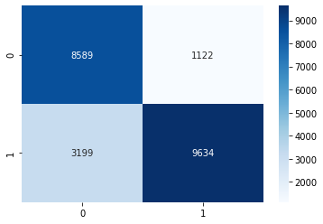
Fig 8.7. Heatmap of Isolation Forest
    - AutoEncoders

AutoEncoder is an unsupervised Artificial Neural Network that compresses data into lower dimensions (bottleneck layer or code) and then decodes the data to recreate the original input.
In anomaly detection, AutoEncoders are commonly employed. We used the reconstruction error as the anomaly scores. We consider a data point to be an anomaly if the reconstruction error exceeds a particular threshold.

We employed two different types of autoencoders:
- Simple Autoencoder
- Stacked Autoencoder

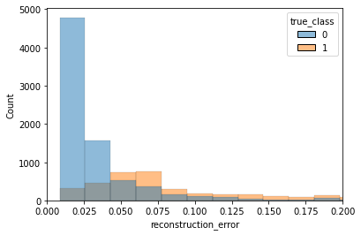
Fig 8.8. Simple Autoencoder - true labels vs the reconstruction error

At the threshold value of 0.56, the maximum accuracy was achieved.
Using the Simple Autoencoder approach, we were able to achieve an accuracy of 81.9 percent.
The approach for Stacked Autoencoder differs from that of the Simple Autoencoders. We train and feed the data through an Autoencoder in this method, except this time we choose two threshold values.

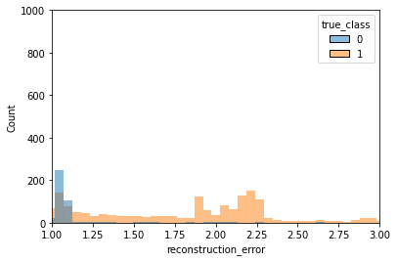
Fig 8.9. Graph to calculate upper limit

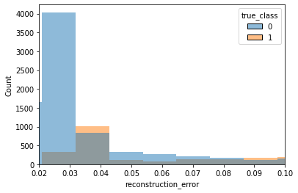
Fig 8.10 Graph to calculate lower limit

As can be seen in the figures 8.9 and 8.10, numbers below the threshold of 0.026 are deemed normal, while those over the threshold of 1.75 are regarded anomalies. All the values that fall within this range are then fed as data to the second Autoencoder, which classifies the data as anomalous or normal once more.

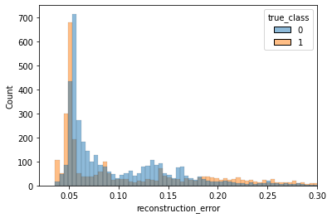
Fig 8.11. Threshold for stacked autoencoders

We established threshold between 0.56 and 1.8 since most normal data falls within that range, and anything outside of it is considered anomalous. We attain the highest accuracy of 87.1 percent by employing Stacked Autoencoders.

8.4 Results and discussion

Table 1. Model Evaluation Scores

Model | Accuracy | F1-score | Precision | Recall
Random Forest | 76.0 | 74.0 | 96.7 | 59.9
AdaBoost | 79.1 | 79.0 | 96.7 | 66.8
Logistic Regression | 73.6 | 71.5 | 92.4 | 58.4
LinearSVM | 78.4 | 78.2 | 92.0 | 68.0
OneClassSVM | 75.6 | 75.0 | 76.0 | 75.0
Isolation Forest | 80.8 | 81.0 | 81.0 | 82.0
Simple Autoencoder | 81.9 | 82.8 | 89.8 | 76.9
Stacked Autoencoder | 87.1 | 88.5 | 86.8 | 90.3

In terms of accuracy, Stacked Autoencoder had the best performance, achieving an accuracy of 87.1% on test data. AdaBoost had the highest accuracy from traditional binary classification techniques. As we can see from the model evaluation scores, autoencoders trained on one class data performed better compared to binary classification models. Anomalies have to be detected and thus require an unconventional machine learning approach. The stacked autoencoder was a custom system that used thresholds calculated from graphs of reconstruction error. Although binary classification models do not perform too poorly, they are still prone to zero-day attacks, which are better dealt with through autoencoders using OneClass approach.

8.5 Conclusion

The outcome of the analysis showcases that machine learning models trained using only the normal data from training dataset perform better in terms of anomaly detection, having a considerable difference in terms of accuracy compared to traditional binary classification methods. A system of autoencoder which includes two autoencoders, with one being a sparse autoencoder achieved the highest testing accuracy of 87%. The NSL KDD, due to the variety of attacks included, is one of the best publicly available dataset to train models for an Intrusion Detection System. Adversarial Machine Learning techniques can be employed to strengthen our IDS, which can help find weaknesses in the training data. Further classification of anomalies into attack types can be attempted using classification techniques.

References
- Gharib, M., Mohammadi, B., Dastgerdi, S. H., & Sabokrou, M. (2019). Autoids: auto-encoder based method for intrusion detection system. arXiv preprint arXiv:1911.03306.
- Ravipati, R. D., & Abualkibash, M. (2019). A survey on different machine learning algorithms and weak classifiers based on KDD and NSL-KDD datasets. International Journal of Artificial Intelligence and Applications (IJAIA), 10(3).
- Dhanabal, L., & Shantharajah, S. P. (2015). A study on NSL-KDD dataset for intrusion detection system based on classification algorithms. International journal of advanced research in computer and communication engineering, 4(6), 446-452.
- Hasan, M. A. M., Nasser, M., Pal, B., & Ahmad, S. (2013). Intrusion detection using combination of various kernels based support vector machine. International Journal of Scientific & Engineering Research, 4(9), 1454-1463.
- Homoliak, I., Breitenbacher, D., & Hanacek, P. (2017). Convergence Optimization of Backpropagation Artificial Neural Network Used for Dichotomous Classification of Intrusion Detection Dataset. J. Comput., 12(2), 143-155.
- Imran, H. M., Abdullah, A. B., & Palaniappan, S. (2013). Towards the Low False Alarms and High Detection Rate in Intrusions Detection System. International Journal of Machine Learning and Computing, 3(4), 332.
- Revathi, S., & Malathi, A. (2013). A detailed analysis on NSL-KDD dataset using various machine learning techniques for intrusion detection. International Journal of Engineering Research & Technology (IJERT), 2(12), 1848-1853.
- Tavallaee, M., Bagheri, E., Lu, W., & Ghorbani, A. A. (2009, July). A detailed analysis of the KDD CUP 99 data set. In 2009 IEEE symposium on computational intelligence for security and defense applications (pp. 1-6). Ieee.
- Chalapathy, R., & Chawla, S. (2019). Deep learning for anomaly detection: A survey. arXiv preprint arXiv:1901.03407.
- Steinwart, I., Hush, D., & Scovel, C. (2005). A Classification Framework for Anomaly Detection. Journal of Machine Learning Research, 6(2).
- Lane, T., & Brodley, C. E. (1997, October). An application of machine learning to anomaly detection. In Proceedings of the 20th national information systems security conference (Vol. 377, pp. 366-380). Baltimore, USA.
- Sakhare, N. N., & Joshi, S. A. (2015). Classification of Criminal Data Using J48-Decision Tree Algorithm. Int. J. Data Warehous. Min, 4(3), 167-171.

